Y NIRANJAN REDDY
DIMENSION TABLE FOR DIM_TOWER:

🧾 Description
This mapping loads unique tower information from the staging table into the DIM_TOWER dimension table. It implements incremental loading by inserting only new tower records.

🔄 Mapping Flow
STG_CDR
↓
Expression
↓
Aggregator (Distinct Towers)
↓
Lookup (DIM_TOWER)
↓
Filter (New Records)
↓
Sequence Generator
↓
DIM_TOWER

🧩 Transformation Details

🔹 Expression
Passes tower-related fields:
TOWER_ID

🔹 Aggregator
Removes duplicates:
GROUP BY TOWER_ID

🔹 Lookup
Checks existing records:
Condition: TOWER_ID = TOWER_ID

🔹 Filter
Implements incremental logic:
ISNULL(LKP_TOWER_KEY)

🔹 Sequence Generator
Generates surrogate key:
TOWER_KEY = NEXTVAL

🧱 Target Table: DIM_TOWER
TOWER_KEY NUMBER PRIMARY KEY,
TOWER_ID VARCHAR2(50)

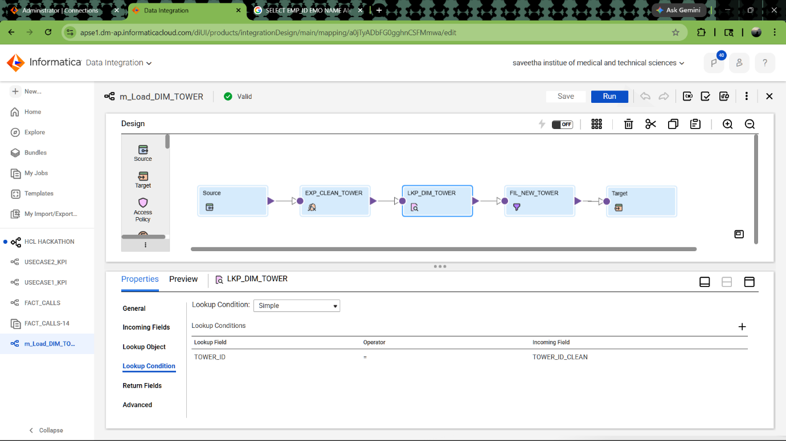
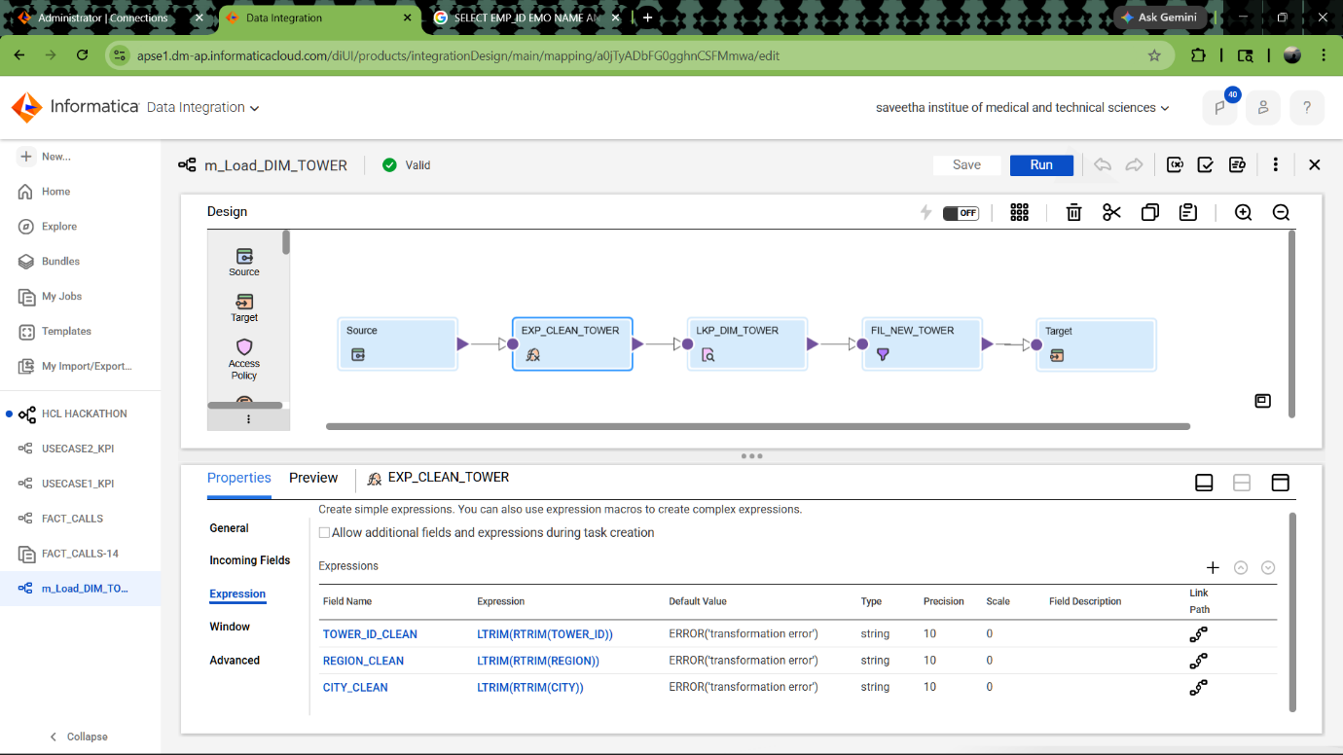

T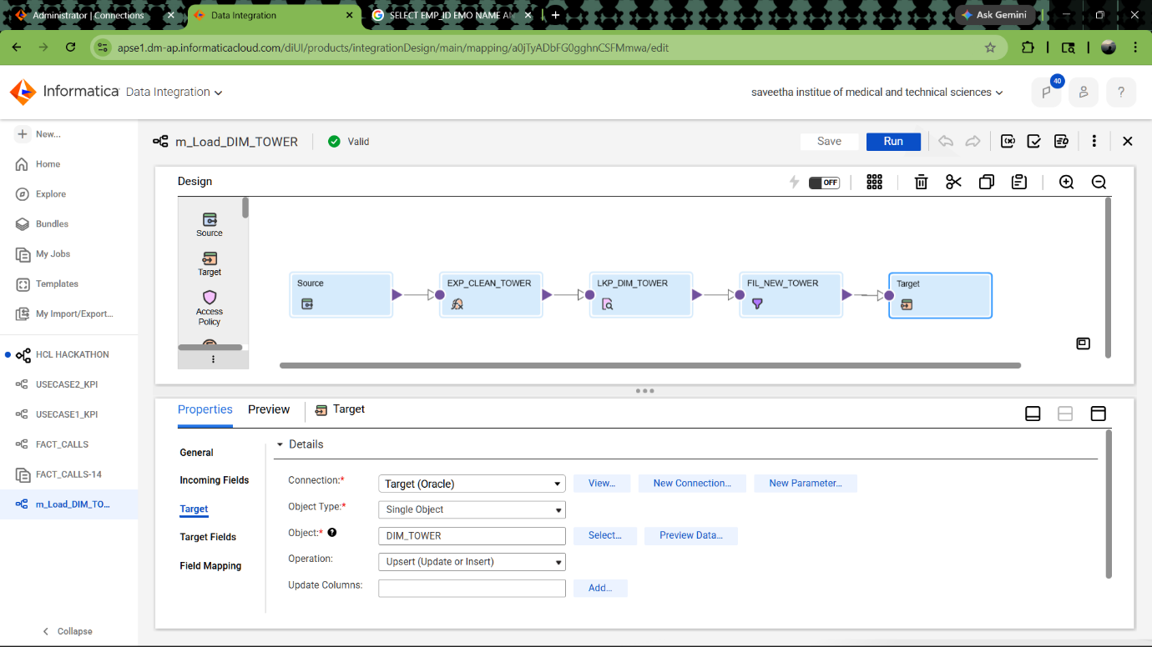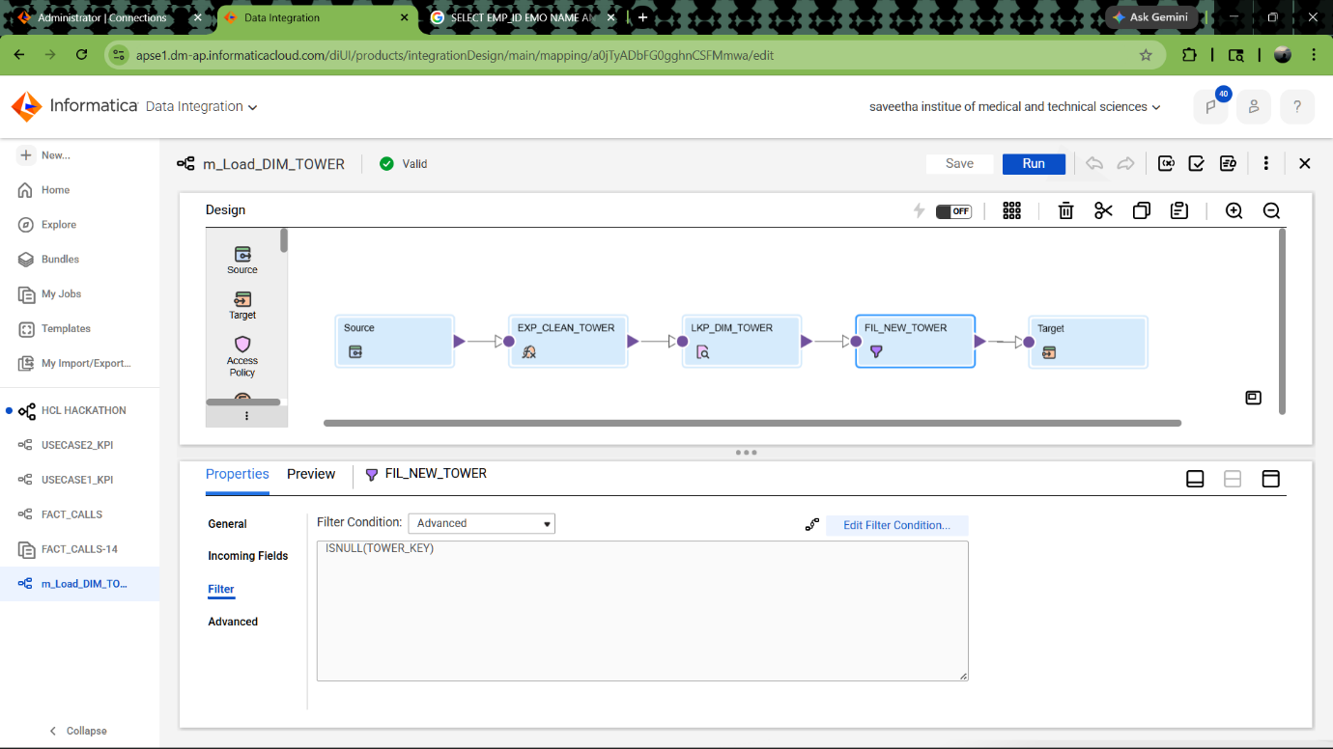

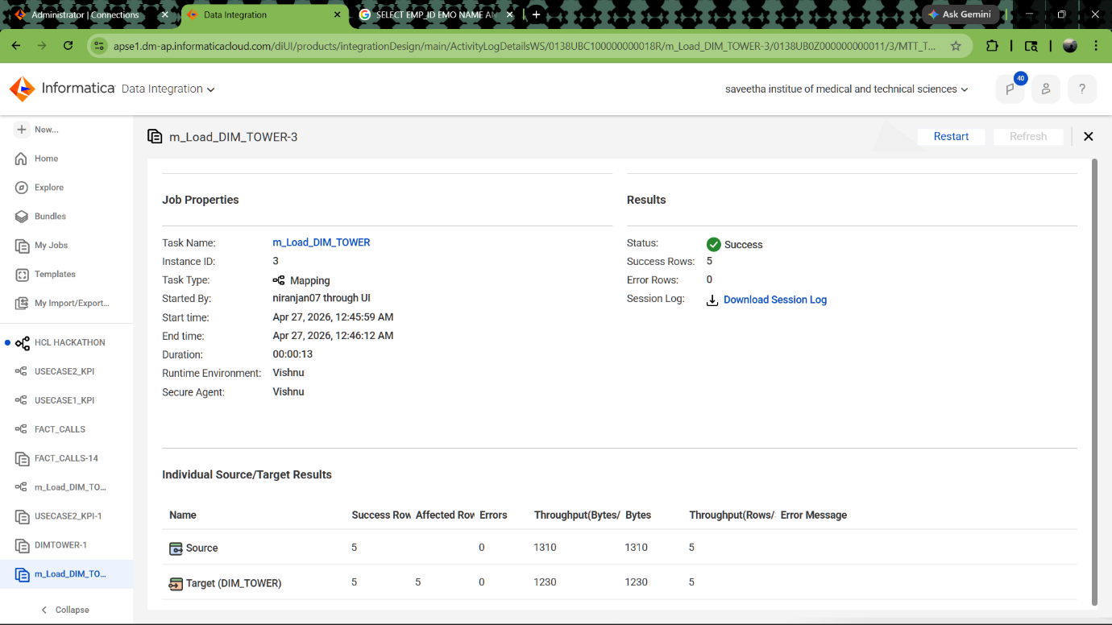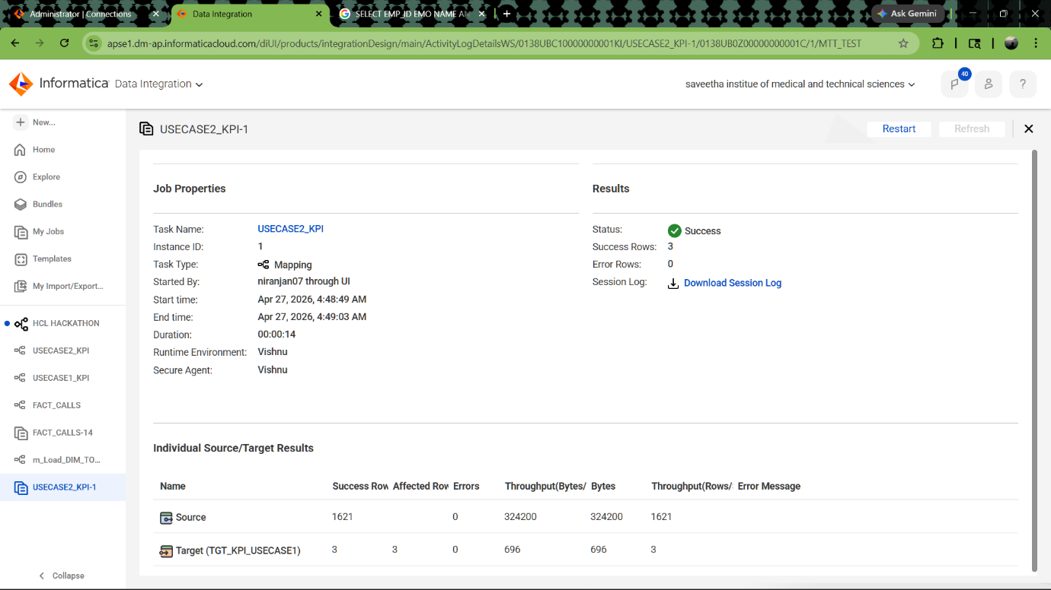📄 1. TASKFLOW DOCUMENTATION

📌 Taskflow

🧾 Description
This taskflow orchestrates the end-to-end ETL process for loading data from staging tables into dimension and fact tables, followed by KPI computation. It ensures proper execution order and dependency handling.

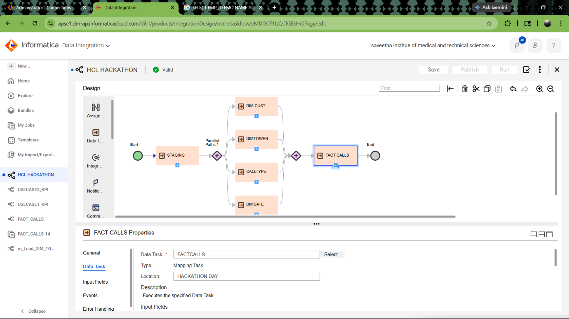

📄 KPI USE CASE 2 – CALL TYPE PERFORMANCE

📌

🧾 Description
This mapping calculates performance metrics for different call types (e.g., Local, STD, ISD) based on call data. It helps analyze usage patterns and revenue contribution per call type.

🔄 Mapping Flow
FACT_CDR
↓
Aggregator
↓
Expression
↓
KPI_CALL_TYPE

🧩 Transformation Details

🔹 Aggregator
Group By:
CALL_TYPE
Measures:
TOTAL_CALLS = COUNT(CALL_ID)
TOTAL_DURATION = SUM(DURATION)
TOTAL_REVENUE = SUM(DURATION * 0.02)

🔹 Expression
AVG_REVENUE =
IIF(TOTAL_CALLS=0, 0,
TOTAL_REVENUE / TOTAL_CALLS)

🧱 Target Table: KPI_CALL_TYPE
CALL_TYPE VARCHAR2(20),
TOTAL_CALLS NUMBER,
TOTAL_DURATION NUMBER,
TOTAL_REVENUE NUMBER,
AVG_REVENUE NUMBER

📊 Business Insights
- Identifies most frequently used call type
- Measures revenue contribution per call type
- Helps in pricing and usage analysis
